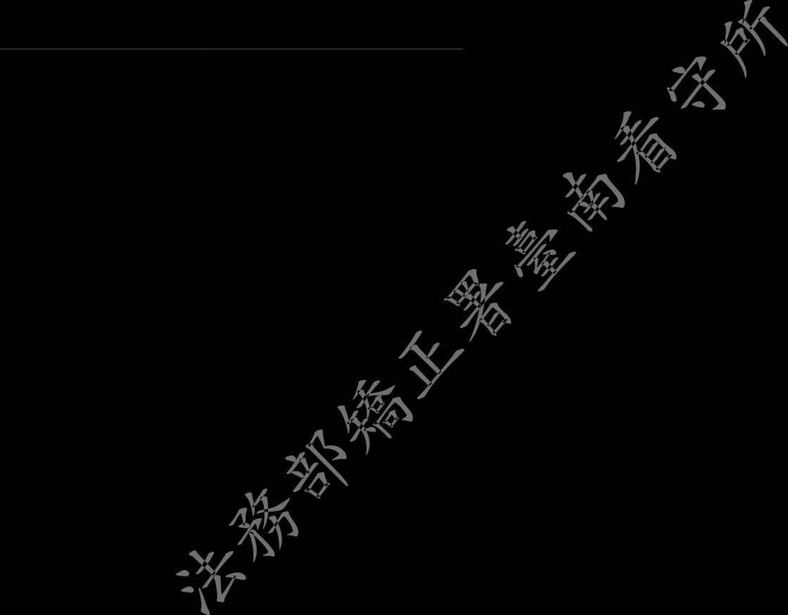
法務部矯正署臺南看守所 禁見被告親屬送入物品單
Tainan Detention Center, Agency of Corrections, Ministry of Justice
年(Y) 月(M) 日(D)
Relative delivery itme(s) to a defendant held incommunicado application form
被告編號  Defendant No. | 姓名  Defendant Name |  | 申請人身分證影本(正反面)黏貼處  Copies of applicant's ID card(both side)
寄物品名 Delivery item list
以上物品為 □自己製作
Item(s) above was/were homemade
□外購店名及住址
purchased from (shop name and adress)
申請人簽名或蓋章 Applicant’s signature or stamp |  | 申請人住址 Applicant’s Address
依據：臺灣高等法院檢察署 88.08.17 檢英所甲字第○二一三九八號函。依函示未登記購自何處，視同自已製作，如涉及違法，自負責任；本單隨物品，由分送食品主管，遂級送值班人員檢查及簽章後，交由物檢主任保管存查之。
Depend：The administrative rule was enacted by Taiwan High Prosecutors Office, Jian-Ying-Sou-Jia No.021398, on August 17,1999.
According to the administrative rule, if an applicant doesn’t indicate where the item(s) was/were purchased from, it shall be
considered as homemade, and the applicant should bear all legal liability if he is involved in any violation of the law.
This application form with item(s) shall be processed by food-deliver controller, after being checked and affixed stamp by duty officer, shall be filed by item-check controller.

